**Department of Computing**

**CS-213: Advanced Programming**

**Class: BSCS 7AB**

**Lab 08: React JS**

**Date: 07 November, 2019**

**Time: 10:00-01:00pm & 02:00-05:00pm**

**Instructor: Dr. Sidra Sultana**

**Lab Engineer: Ms. Ayesha Asif**

## Name: Amna Muqeem

## Class: BSCS 7B

## CMS ID: 216259

# TASKS

1. **You have to practice the states codes covered in class lecture**

## Example 1:

**App.js**

import React, {Component} from 'react';

import './App.css';

import Welcome from './Welcome';

class App extends Component{

render(){

return (

<div>

<Welcome></Welcome>

</div>

)

}

}

export default App;

**Welcome.js:**

import React,{Component} from 'react';

class Welcome extends Component {

constructor(){

super()

this.state={message:'welcome visitor'}

}

changeMessage(){

this.setState({

message: 'Thank you for subscribing'

})

}

render(){

return (

<div>

<h1>{this.state.message}</h1>

<button onClick={()=>this.changeMessage()}>Subscribe</button>

</div>

)

}

}

export default Welcome;

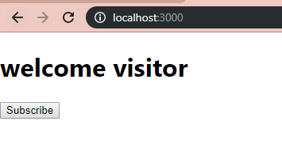

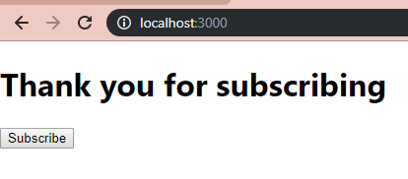

## Example 2:

import React,{Component} from 'react';

class Welcome extends Component {

constructor(props){

super(props)

this.state={ count:0 } }

Increment(){

this.setState({

count:this.state.count+1

})

console.log(this.state.count)

}

render(){

return (

<div>

<h1>counter - {this.state.count}</h1>

<button onClick={()=>this.Increment()}>Increment</button>

</div>

)

}

}

export default Welcome;

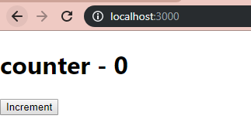

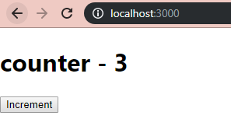

## Example 3:

import React,{Component} from 'react';

class Welcome extends Component {

constructor(props){

super(props)

this.state={ count:0 } }

Increment(){

this.setState({

count:this.state.count+1}, ()=>{console.log('call back value',this.state.count)}

)

console.log(this.state.count);

}

render(){

return (

<div>

<h1>counter - {this.state.count}</h1>

<button onClick={()=>this.Increment()}>Increment</button>

</div>

)

}

}

export default Welcome;

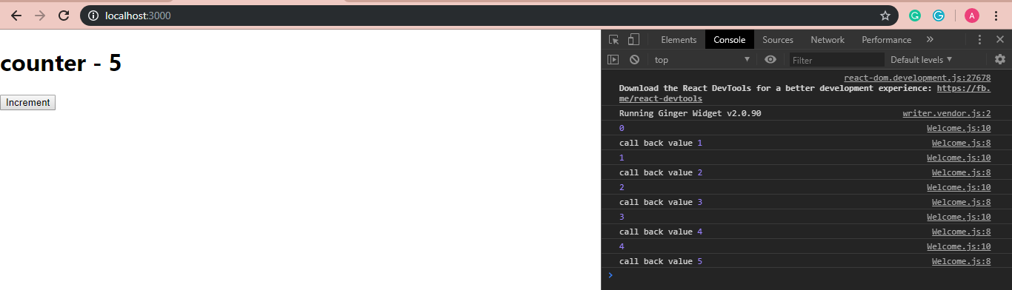

## Example 4:

import React,{Component} from 'react';

class Welcome extends Component {

constructor(props){

super(props)

this.state={ count:0 } }

increment(){

this.setState((state)=> {

return {count:state.count+1}

}, ()=>{console.log('call back value',this.state.count)}

);

console.log(this.state.count);

}

incrementFive() {

this.increment();

this.increment();

this.increment();

this.increment();

this.increment();

}

render(){

return (

<div>

<h1>counter - {this.state.count}</h1>

<button onClick={()=>this.incrementFive()}>Increment</button>

</div>

)

}

}

export default Welcome;

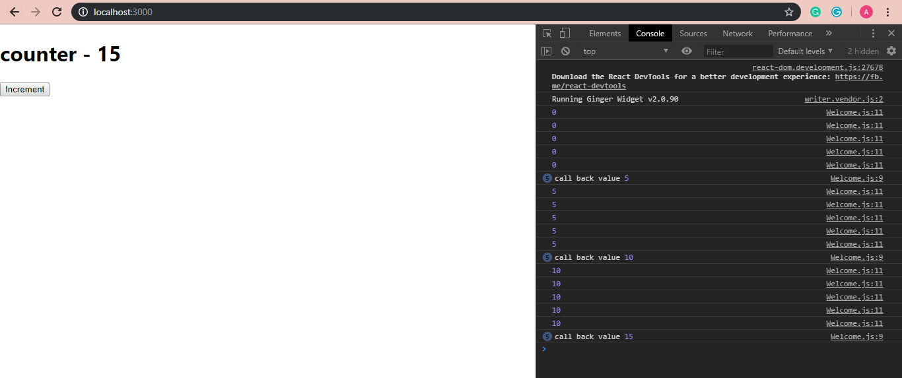

## Example 5:

import React,{Component} from 'react';

class Welcome extends Component {

constructor(props){

super(props)

this.state={ count:0 } }

increment(){

this.setState((prevState)=> {

return {count:prevState.count+1}

}, ()=>{console.log('call back value',this.state.count)}

);

console.log(this.state.count);

}

render(){

return (

<div>

<h1>counter - {this.state.count}</h1>

<button onClick={()=>this.increment()}>Increment</button>

</div>

)

}

}

export default Welcome;

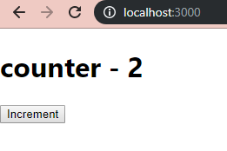

1. **Create a timer application which asks the user for minutes. The user then click Start button and starts the timer count down. Preview @ <https://7zyz2y4p5j.csb.app/>**

## Timer.js

import React from 'react';

import {Component} from 'react';

import './App.css';

class Timer extends Component{

render(){

return (

<div>

<h1>{this.props.minutes}:{this.props.seconds}</h1>

</div>

)

}

}

export default Timer;

## App.js

import React from 'react';

import {Component} from 'react';

import Timer from './Timer';

import './App.css';

class App extends Component{

constructor(props){

super(props);

this.state = { seconds:'00', minutes:'00'

}

this.time = 0;

this.intervalHander = 0;

this.startTimer = this.startTimer.bind(this);

this.handleChange = this.handleChange.bind(this);

this.ticking = this.ticking.bind(this);

}

handleChange(event){

this.setState({minutes: event.target.value}, ()=>{console.log(this.state.minutes)})

}

startTimer(){

this.time= (this.state.minutes)*60;

this.intervalHandler = setInterval(this.ticking, 1000);

document.getElementById("input").style.display = "none";

document.getElementById("button").style.display = "none";

}

ticking(){

if (this.time === 0){

document.getElementById("input").style.display = "block";

document.getElementById("button").style.display = "block";

document.getElementById("input").style.marginLeft = "200px";

document.getElementById("button").style.marginLeft = "250px";

clearInterval(this.intervalHandler);

}

var min = Math.floor(this.time/60);

var sec = this.time%60;

if (min<10 && sec < 10){

this.setState({ minutes: "0"+min, seconds:"0"+sec })

}

else if (sec < 10){

this.setState({ minutes: min, seconds:"0"+sec })

}

else if (min < 10){

this.setState({ minutes: "0"+min, seconds:sec })

}

else{

this.setState({ minutes: min, seconds:sec })

}

this.time--;

}

render(){

return(

<div className="App">

<h1> Timer Task 2 </h1>

<input id="input" type="number" onChange={this.handleChange} required />

<Timer minutes={this.state.minutes} seconds={this.state.seconds} />

<button id="button" onClick={this.startTimer}>Start!</button>

</div>

);

}

}

export default App;

